**Erum Iqbal and Aisha Essa**

**Project: Tic-Tac-Toe**

**Description:**

Tic-Tac-Toe is a very simple two-player game. One player plays with X, and the other player plays with O. In this game, we have a board consisting of a 3X3 grid.

.Only one player can play at a time. Condition for wining is whoever places three respective marks (X or O) horizontally, vertically, or diagonally will be the winner.

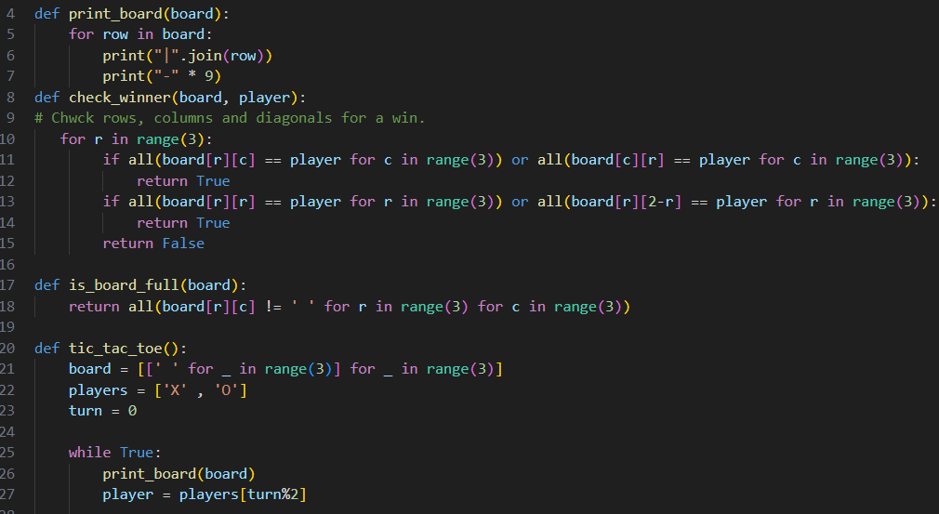

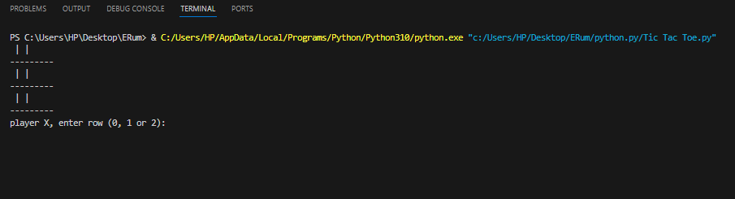

<https://github.com/ErumIqb/BanoQabil-2.0-Python-Course>